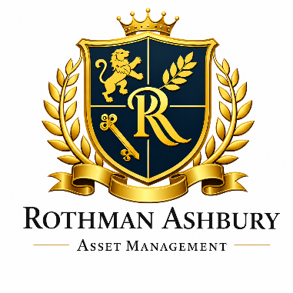

ROTHMAN ASHBURY ASSET MANAGEMENT

WEBSITE CONTENTS

SOURCES OF INSPIRATION

https://ewmgroup.com.au/ (except the entire home page content should be viewable without having to scroll down. Also I don’t want the dark feel; I prefer a light/airy feel)

Also below are some sample mock up websites (using Brisbane imagery) to give you some idea of what I have in mind:

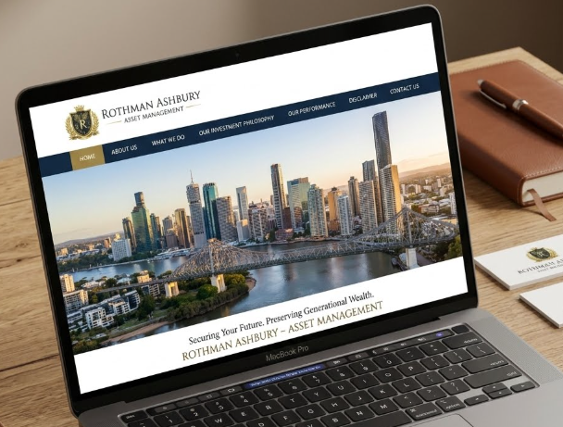

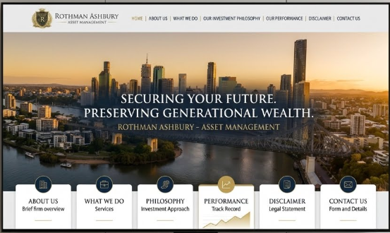
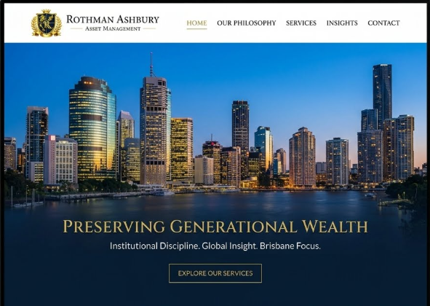



HOME PAGE

Rothman Ashbury Asset Management is a private single‑family office dedicated to stewarding the capital of its owners with patience, discipline and a long view of the world.

Our work is quiet, deliberate and grounded in the time‑tested principles of value investing — the same principles taught by the legendary Benjamin Graham and carried forward by superinvestors, Warren Buffett and Charlie Munger.

We allocate capital across shares, bonds, property, private equity and the occasional opportunity that genuinely earns its place. Everything we do is for the family alone; we do not accept clients, outside investors or public enquiries.

ABOUT US

Rothman Ashbury Asset Management was founded with a simple purpose: to manage the financial affairs of a single family in a careful, thoughtful and long‑term manner. That purpose may sound modest, but it carries a great deal of responsibility.

When you are looking after a family’s capital - not for a quarter, not for a year, but for decades - you must think clearly, act rationally and behave with the kind of steadiness that does not depend on market moods.

The mindset behind our company has been shaped over many years of reading, studying and observing the world’s most rational investors.

We have learned from the seminal writings of Benjamin Graham, the partnership letters of Warren Buffett, the practical wisdom of Charlie Munger and the quiet discipline of many long‑term owners who rarely make headlines but consistently make good decisions. Their ideas have influenced how we think about risk, opportunity, temperament and time — and those ideas form the backbone of our approach.

Over time, we also hope to play a small part in keeping the tradition of rational, long‑term investing alive. The world of finance is often loud, impatient and easily distracted, but the principles of value investing have a way of cutting through the noise. They reward clear thinking, steady temperament and a willingness to look past the next headline. If we can help preserve and quietly promote that way of thinking — even in our own limited corner of the investment world — we consider that a worthwhile contribution.

We operate from Brisbane, but our perspective is global. The family’s capital is not confined to any one market or geography. We study opportunities in Australia, the United States, Europe and Asia. We look at businesses in dozens of industries — from consumer goods to healthcare, from infrastructure to technology, from financial services to industrials.

We consider property markets, credit markets, private equity opportunities, and, when the economics justify it, selected alternative investments. Our job is to understand the world well enough to make sensible decisions within it.

We are deliberately small in structure but broad in capability.

A family office does not need layers of hierarchy or sprawling teams. What it needs is clarity of thought, discipline of process and a willingness to do the unglamorous work that long‑term stewardship requires. We spend our time reading, analysing, discussing, planning and thinking — not rushing, reacting or chasing.

We measure success not by the size of our office or the number of people on our payroll, but by the quality of our decisions and the long‑term growth of the family’s economic strength.

Our approach is grounded in partnership thinking. We do not think like fund managers trying to outperform a benchmark each quarter. We think like owners trying to build enduring value over many years. That difference in mindset shapes everything — from how we allocate capital to how we define risk to how we respond when markets become volatile.

We are not a fund manager, financial adviser or investment product provider. We do not solicit or accept external money. We do not promote strategies, publish forecasts or offer services to the public. Everything we do is for our owners alone. Our work is private, long‑term and inward‑facing — and we intend to keep it that way.

In short, Rothman Ashbury exists for one purpose: to steward the family’s capital with care, clarity and common sense. That is our mandate, our responsibility and our commitment.

WHAT WE DO

If you were to sit with us for a day, you’d notice that our work is not loud, flashy or hurried. It’s quiet, steady and deeply focused. We spend most of our time thinking — about businesses, about risks, about incentives, about long‑term economics and about how to make sensible decisions with the capital entrusted to us.

That is the heart of what we do.

Rothman Ashbury Asset Management Pty Ltd is a private single‑family office. We manage only one pool of capital: the family’s. We do not manage external money, we do not offer services to the public and we do not promote investment products. Everything we do is inward‑facing, long‑term and grounded in the principles of rational ownership.

Our work spans a wide universe of possibilities. We study listed companies across Australia and around the world — businesses in sectors as varied as consumer staples, industrials, financials, healthcare, technology, energy, utilities, telecommunications, transportation, infrastructure, real estate and materials.

We look at companies that make toothpaste, companies that build bridges, companies that run airports, companies that design software and companies that keep the lights on. If a business produces something useful, earns good returns on capital and has a durable competitive advantage, it earns a place on our radar.

We also look beyond listed markets. Our universe includes residential and commercial property, industrial property, agricultural land, infrastructure assets, private equity opportunities and occasionally alternative investments when they serve a clear purpose.

We may invest in bonds — government, corporate or otherwise — when they offer a sensible balance of safety and return. And from time to time, we may use derivatives such as call or put options, not for speculation, but for risk management or strategic positioning when the odds are clearly in our favour.

In short, we study a wide range of asset classes:

- Australian and international equities
- Fixed income and credit
- Direct and indirect property
- Private equity and private businesses
- Infrastructure and real assets
- Cash and cash‑equivalents
- Selective derivatives used prudently
- Alternative investments when justified by economics

But studying is only half the work.

The other half is deciding how to allocate capital among these possibilities. We do not follow rigid formulas or mechanical models. Instead, we use a simple, common‑sense approach: we look for the most attractive opportunities available to us at any given time and we size our positions according to their risk, their quality and our level of conviction.

Our asset allocation is guided by a few principles. We prefer to own productive assets — businesses that generate cash and can reinvest it at good rates of return. We maintain flexibility so we can act when opportunities arise. We avoid excessive leverage because it can turn temporary volatility into permanent loss.

And we keep a margin of safety in everything we do, whether we are buying shares, evaluating a property, or considering a private investment.

Security selection — choosing what to own — follows the same philosophy. We look for businesses with strong economics, honest and capable management, durable competitive advantages and sensible capital allocation. We prefer companies that treat shareholders like partners and that think in decades rather than quarters. We study balance sheets, income statements, industry dynamics, competitive positioning and long‑term prospects. And we only act when the price gives us a margin of safety.

We also spend time doing the quieter work that a family office requires: record‑keeping, risk oversight, governance, reporting, tax coordination and long‑term planning. These tasks may not be glamorous, but they are essential. Good stewardship is not just about making investments; it is about managing the entire financial ecosystem of the family with care and clarity.

Everything we do is guided by one idea: make rational, long‑term decisions that strengthen the family’s financial position over time. We do not chase fads, forecasts or fashionable narratives. We do not try to predict markets. We do not act because others are acting. We act when the economics make sense, the risks are understood and the long‑term prospects are favourable.

And because we are a private single‑family office, we do not accept external clients, external capital or external enquiries about financial products or services. Our work is for the family alone — steady, thoughtful and built to endure.

OUR INVESTMENT PHILOSOPHY

If you were to boil our philosophy down to one sentence, it would be this: we try to behave like rational owners of productive assets, not traders of paper whose prices wiggle around each day.

That single idea sits at the centre of everything we do.

It shapes how we think about risk, how we evaluate opportunities and how we respond to the inevitable ups and downs of markets. It also keeps us grounded when the world becomes noisy - and the world is almost always noisy.

We think of investing the way you might think about owning a farm, a small business, or a rental property. You wouldn’t check the price every hour. You’d care about the soil, the harvest, the tenants, the cash flow, the long‑term prospects. You’d judge success by the durability of the enterprise, not the chatter of the crowd.

We try to bring that same mindset to the public markets and to every other investment we make, whether it’s a listed company, a bond, a property or a private business.

Our approach draws heavily from the value‑investing tradition taught by Benjamin Graham, expanded by Warren Buffett and Charlie Munger and refined by many thoughtful investors over the decades. These principles are simple to state but require discipline, temperament and a willingness to look wrong in the short run in order to be right in the long run.

They are not shortcuts.

They are not formulas.

They are habits of mind - and we try to practise them every day.

We also recognise that investing is not a game of perfect foresight. It is a game of probabilities, judgment and behaviour. The future is uncertain and the world is full of surprises. But a sound philosophy gives you a compass — a way to navigate uncertainty without being tossed around by every gust of wind.

The principles below form that compass for us and we try to apply them with steadiness, humility and common sense.

1. Think like owners.

When we buy shares, we see ourselves as buying a piece of a business, not a trading chip or a lottery ticket. That means we care about the economics of the enterprise: its competitive position, its management, its ability to reinvest capital sensibly and its long‑term prospects.

We ask whether the business can grow its earning power over time, whether it treats shareholders like partners and whether it has the resilience to withstand adversity.

Thinking like owners also changes how we respond to volatility. When prices fall, we don’t view it as a verdict on our intelligence; we view it as an opportunity to increase our ownership at better prices. When prices rise, we don’t assume we’ve become geniuses; we simply recognise that markets fluctuate.

This mindset keeps us calm when others are anxious and patient when others are restless. It also reminds us that our job is not to predict the market’s mood but to understand the business we own.

Most importantly, thinking like owners aligns our behaviour with the long‑term interests of our family. Owners care about durability, stewardship and compounding. Traders care about price movements. We know which group we want to belong to — and we behave accordingly.

2. Insist on a margin of safety.

We prefer situations where the odds are clearly tilted in our favour — where the price we pay is meaningfully below our estimate of intrinsic value. This gap is our margin of safety, a buffer against errors in judgment, unexpected events, or plain bad luck.

It acknowledges that the future is uncertain and that even the best analysis contains blind spots.

A margin of safety also gives us emotional resilience. It allows us to hold through volatility because we know we bought with room to spare. It encourages patience because we don’t need perfection to achieve a satisfactory outcome. And it keeps us humble because it reminds us that investing is not about precision; it is about making sensible decisions in an uncertain world.

A good margin of safety turns uncertainty from a threat into a manageable companion. It allows us to act decisively when opportunities arise and to remain steady when markets become turbulent. It is one of the oldest principles in investing — and one of the most enduring.

3. Favour quality.

Warren Buffett pointed out that a wonderful business at a fair price beats a fair business at a wonderful price.

High‑quality businesses — those with durable competitive advantages, strong customer loyalty, sensible capital allocation and the ability to compound earnings over time — tend to surprise on the upside. Mediocre businesses tend to do the opposite.

Quality shows itself in many ways: consistent profitability, prudent use of debt, honest and capable management and a business model that can endure competition and change. When you own a high‑quality business, time becomes your ally. When you own a fragile business, time becomes your enemy.

We would rather pay a reasonable price for a company with staying power than a bargain price for a company fighting structural decline. Quality compounds; fragility erodes. And in a world full of uncertainty, owning resilient, adaptable businesses is one of the best protections an investor can have.

4. Be patient.

Opportunities come in clusters and droughts.

We don’t force action simply because we feel the need to “do something.” Patience is not passive; it is an active decision to wait for the right pitch. When markets are expensive or opportunities scarce, we are content to hold cash or lower‑risk assets. When fear returns and prices become attractive, we act decisively.

Patience also applies to holding. Once we own a good business, we prefer to let compounding do the heavy lifting. Selling too early is one of the most common and costly mistakes in investing. We try to avoid it by reminding ourselves that wealth is often built not by constant activity but by long periods of intelligent inactivity.

Patience is a competitive advantage because so few people practise it.

The world rewards speed, novelty and constant motion. We prefer steadiness, clarity and long‑term thinking. Time is the friend of the wonderful business and the enemy of the poor one.

5. Avoid leverage that can keep you up at night.

We would rather sleep well than reach for a few extra points of return. Debt can magnify outcomes, but it can also magnify mistakes. We prefer structures that allow us to endure storms, not merely enjoy sunshine.

Our goal is to ensure that no single event - market, economic or otherwise - can jeopardise the financial stability of the family we serve.

Avoiding excessive leverage also keeps us rational.

When you are over‑leveraged, volatility becomes frightening. When you are conservatively positioned, volatility becomes opportunity. We want the freedom to act when others are paralysed and that freedom comes from maintaining a balance sheet that can withstand shocks.

Safety first, returns second. That hierarchy never changes. And in our experience, the investors who survive the longest tend to do the best — because survival gives compounding the time it needs to work its quiet magic.

6. Ignore market noise.

A falling market is not a signal to panic; it is often a chance to buy more of what we already understand. We do not react to headlines, predictions or short‑term volatility.

Markets will always fluctuate — sometimes wildly — but the underlying value of a business changes far more slowly.

Ignoring noise requires emotional discipline. It means resisting the urge to respond to every market twitch or every confident forecast. It means remembering that the market is a voting machine in the short run but a weighing machine in the long run (Benjamin Graham).

And it means anchoring ourselves to long‑term fundamentals rather than short‑term sentiment.

When prices fall for reasons unrelated to business value, we view it the way a farmer views cheaper land: an opportunity, not a threat. Noise is constant. Value is enduring. We try to focus on the latter.

7. Be candid with ourselves.

When we make mistakes - and we will - we acknowledge them, study them and learn from them. Self‑deception is the enemy of good judgment.

We try to be brutally honest about what worked, what didn’t and why. This candour helps us refine our process, avoid repeating errors and maintain the humility necessary to navigate an uncertain world.

Candid self‑assessment also keeps us grounded. It reminds us that investing is a lifelong learning process, not a destination. It encourages intellectual honesty, which is far more valuable than intellectual brilliance. And it helps us build a culture where truth matters more than ego.

Good investing is less about brilliance and more about avoiding unforced errors. Candour is how we keep ourselves on that path.

8. Think long‑term.

We try to make decisions with the next decade in mind, not the next quarter. A long‑term perspective is one of the few genuine advantages an investor can have, because it allows you to ignore the noise, the forecasts, the fads and the endless commentary that dominate the short-term landscape.

When you think long‑term, you stop worrying about whether a stock will be up or down next week and start focusing on whether the underlying business will be stronger, more profitable and more resilient five or ten years from now.

Thinking long‑term also changes how you behave. It encourages patience, because you understand that good businesses need time to grow and compound. It encourages discipline, because you realise that temporary market swings are irrelevant to the long arc of value creation. And it encourages calmness, because you know that volatility is not a verdict — it is simply the price of admission for long‑term ownership.

Most importantly, a long‑term mindset aligns perfectly with our role as owners. Families build wealth over generations, not trading days. We try to make decisions today that our future selves - and future generations - will thank us for. That means avoiding shortcuts, resisting speculation and favouring investments that can steadily compound over many years.

Time is the friend of rational investors and we try to use it to our advantage.

Conclusion

We believe in simplicity.

The world is complicated enough without us adding to the confusion. We try to understand what matters, ignore what doesn’t and stay within our circle of competence. If something is too complex to understand, we simply pass. There are no extra points in investing for difficulty.

Above all, we aim to behave consistently. Markets will rise and fall, headlines will come and go and predictions will always be plentiful. But rationality, discipline and long‑term thinking never go out of style. These principles have served generations of value investors well and we intend to carry them forward with the same steadiness, humility and respect for risk.

Our philosophy is not a promise of results. It is a promise of behaviour — the behaviour of owners, not speculators; of partners, not promoters; of long‑term thinkers, not short‑term chasers. That is the compass we follow and it guides every decision we make.

In the end, investing is not about outsmarting others. It is about avoiding folly, staying patient and letting time do the heavy lifting.

If we can continue to apply these principles with clarity and consistency, we believe we will give the family the best chance of long‑term financial strength - not through brilliance, but through sound judgment practised steadily over many years.

OUR PERFORMANCE

Performance is shown below as a simple factual record of what happened from the time we began operations through to 30 June 2026. Nothing more, nothing less.

It is a short window — just the opening chapter of a much longer story — and short windows rarely tell you much about investing. Markets need time to reveal their character and time has not yet had much time here.

This period represents only part of a financial year, reflecting the early stage of our operations. The numbers below relate solely to the internal investment activities of Rothman Ashbury Asset Management Pty Ltd during that period.

Rothman Ashbury Portfolio | X.XX%
ASX 200 Accumulation Index | X.XX%

We present these figures for one reason only: to keep a clear and honest record of our own history. They are not a forecast, not an endorsement, not a suggestion of skill and not an invitation to draw conclusions about the future. They simply describe what occurred during a brief stretch of time.

Short periods can be misleading.

A few months of returns tell you very little about the long arc of investing, just as a single day’s weather tells you very little about the climate. Markets rise and fall for reasons that often have nothing to do with underlying value. The real test of any investment approach is how it behaves over many years, not many weeks.

We do not present this information to encourage any action or to imply any particular ability. It is merely a factual record - the kind of record any responsible owner would keep for themselves.

Past performance is not a reliable indicator of future performance and we make no suggestion otherwise.

Rothman Ashbury Asset Management is a private company operating solely for the benefit of its owners. We do not accept external clients, external capital or external investment mandates. Everything we do is inward‑facing and this performance information is shared in that same spirit: for completeness, for transparency and for the family alone.

INSIGHTS

Investing rewards clear thinking, steady temperament and a willingness to look past the noise of the moment. The notes and reflections below are our way of putting those habits into writing.

They are rooted in the lineage of thoughtful investors who came before us — from Graham’s analytical foundations to Buffett’s partnership principles, Munger’s clarity of mind, and the enduring practices of owners who have proven that patience and rationality still work.

We publish these pieces not to predict markets or offer advice, but to clarify our own thinking and to help preserve a tradition of rational, long‑term investing in a world that often prefers speed over sense.

What follows is simply a collection of thoughts, observations and lessons that matter to us as owners — shared in the hope that good ideas remain useful long after the headlines fade.

“What the Market Is Getting Wrong About Australia’s Inflation Cycle — And How Long‑Term Investors Should Value Businesses in a High‑Rate World” (10 July 2026)

“The Hidden Risks Inside Australia’s Most Popular Stocks: A Value Investor’s Guide to Earnings Quality, Cash Conversion and Accounting Red Flags” (1 July 2026)

“When Prices Lie: How to Value Australian Companies When the Economic Signals Are Conflicting” (26 June 2026)

“The Illusion of Growth: Identifying Overstated Revenues, Capitalised Costs and Other Accounting Shenanigans on the ASX” (12 June 2026)

“What Rising Yields Mean for Equity Valuation: A Practical Framework for Discount Rates, Risk Premia and Margin of Safety in Today’s Market” (15 May 2026)

“The Difference Between a Good Business and a Good Investment — Lessons from the Current Australian Market Cycle” (1 May 2026)

“How to Analyse Capital‑Intensive Companies in an Inflationary Economy: A Value Investor’s Approach to Depreciation, Maintenance Capex and Real Returns” (17 April 2026)

“The Most Dangerous Line in an Annual Report: How to Spot Management Optimism Before It Costs You Money” (3 April 2026)

“Why Volatility Isn’t Risk: What Recent Market Swings Teach Us About Temperament, Valuation and Long‑Term Ownership” (23 March 2026)

“The Quiet Risks Hiding in High‑Dividend Stocks: Payout Ratios, Balance Sheets and the Illusion of Safety on the ASX” (11 March 2026)

“Earnings That Don’t Tell the Truth: How Inflation, Interest Rates and Management Adjustments Are Distorting Reported Profits on the ASX” (26 February 2026)

“The Real Cost of Growth: A Value Investor’s Guide to Analysing Capex, Working Capital and Free Cash Flow in Capital‑Heavy Australian Businesses” (4 February 2026)

“When Dividends Become Dangerous: Understanding Payout Ratios, Balance‑Sheet Stress and the Hidden Risks in Australia’s High‑Yield Stocks” (24 January 2026)

“The Mirage of ‘Adjusted EBITDA’: How to Spot Over‑Optimistic Reporting, Capitalised Expenses and Other Red Flags in Today’s Market” (2 January 2026)

DISCLAIMER

At Rothman Ashbury Asset Management Pty Ltd, we try to speak plainly about what we do - and just as plainly about what we don’t do.

We are a private single family office, established solely to manage the financial affairs and assets of our owners. That is our entire purpose. We do not hold ourselves out as advisers, managers, promoters or product providers to anyone outside the family group and we have no intention of becoming one.

To avoid any misunderstanding, here is what we do not do:

- We do not provide financial product advice - not general, not personal, not in any form
- We do not provide personal financial advice of any kind
- We do not deal in financial products for others (only for our own family)
- We do not operate, promote or offer a managed investment scheme
- We do not solicit, accept or manage funds from external parties
- We do not offer services to retail or wholesale clients
- We do not invite, encourage or accept investment from anyone outside our ownership group

Everything on this website exists for one audience only: the family that owns the company.

The information here is for internal knowledge, record keeping and clarity of purpose. It is not intended for public use, public reliance or public interpretation. If you are reading this and you are not part of the family group, you should understand that the content is not written for you and must not be relied upon.

Nothing on this website should be taken as:

- A recommendation to buy, sell or hold any financial product
- An offer, invitation, solicitation or inducement to invest
- A prediction or representation of future performance
- A statement of opinion intended to influence any person’s investment decisions
- Financial, legal, tax or accounting advice

Any historical performance information is purely factual, relates only to the assets of the family office and is not a guide to what may happen in the future. Past performance is not a reliable indicator of future performance — and we make no suggestion otherwise.

We also make no representation or warranty about the accuracy, completeness or suitability of any information on this website for anyone other than our owners. Anyone accessing this website from outside the family group does so on the clear understanding that the material is not intended for them and must not be used or relied upon for any purpose.

If you are seeking financial advice, you should speak with an appropriately licensed Australian financial services professional — someone whose role is to advise the public. Ours is not.

CONTACT US

If you ever find yourself visiting our office, you’ll notice something right away: we are not a public‑facing firm. There is no reception desk offering brochures, no sales team waiting to take enquiries and no products to discuss.

We are a private single‑family office and everything we do is directed solely toward the needs of the family we serve.

For that reason, our communication channels are intentionally narrow. We keep them that way not out of secrecy, but out of clarity. We want to ensure that every message we receive relates directly to the work we do for our owners and their authorised representatives. It keeps our focus sharp and our responsibilities clean:

The Managing Director
Rothman Ashbury Asset Management Pty Ltd
ACN 699 507 063
Level 18, 324 Queen Street
Brisbane Qld 4000
Australia

Email: info@rothmanashbury.com.au

So while we are always reachable for matters concerning the family group, we do not accept external clients, investors or enquiries about financial products or services. We do not respond to investment proposals, pitches, introductions or opportunities from outside parties. Our work is inward‑facing by design and our communication reflects that.

If you are part of the family group or an authorised representative, you already know how to reach us — and we are always here when you need us. If you are not, we appreciate your interest, but this is not the right doorway for financial advice, investment discussions or service enquiries. There are many firms built for that purpose. We simply are not one of them.

